# K8S Cluster setup

Prerequists:

1. Download vagrant --> <https://developer.hashicorp.com/vagrant/install#windows>
2. Clone the Vagrantfile file
3. Run **vagrant up**

1. SSH to the three nodes

Steps:

1. Install kubeadm -> <https://v1-31.docs.kubernetes.io/docs/setup/production-environment/tools/kubeadm/install-kubeadm/>

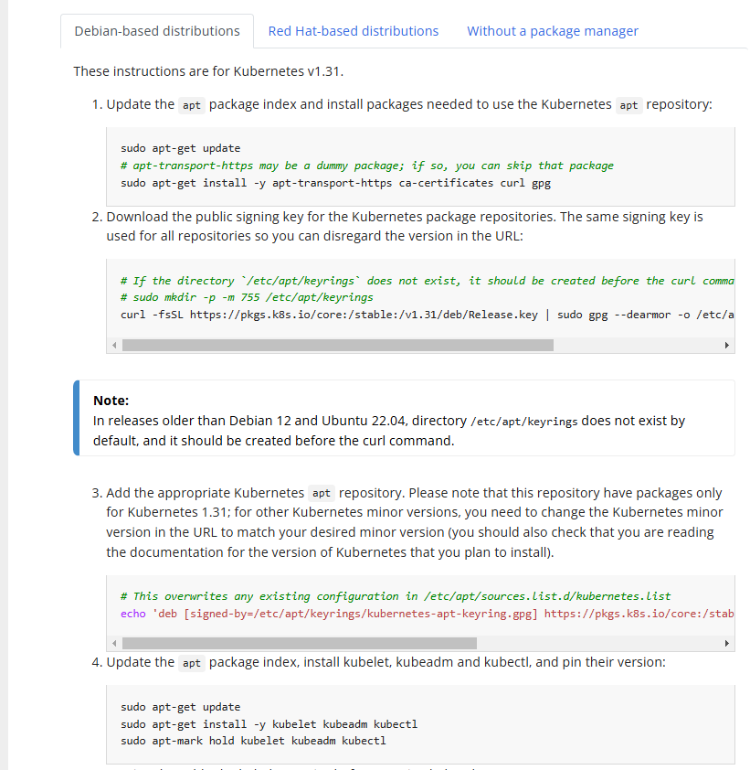

1. Installing containerd
   1. sudo apt-get update
   2. sudo apt-get install containerd -y
2. Configuring Systemd as a cgroup driver for the containerd.
   1. sudo mkdir -p /etc/containerd
   2. containerd config default | sed 's/SystemdCgroup = false/SystemdCgroup = true/' | sudo tee /etc/containerd/config.toml
   3. cat /etc/containerd/config.toml | grep -i systemdcgroup -B 50
   4. sudo systemctl restart containerd
   5. sudo systemctl status containerd
3. Enable IPV4 Packet Forwarding

A)

cat <<EOF | sudo tee /etc/sysctl.d/k8s.conf

net.ipv4.ip_forward = 1

EOF

1. sudo sysctl --system
2. Initating the cluster **on the Master only**
   1. sudo kubeadm init --apiserver-advertise-address <Master_ip> --pod-network-cidr "10.244.0.0/16" --upload-certs
   2. mkdir -p $HOME/.kube

sudo cp -i /etc/kubernetes/admin.conf $HOME/.kube/config

sudo chown $(id -u):$(id -g) $HOME/.kube/config

1. Forward IPV4 and Configure iptables (**on the 3 nodes)**

cat <<EOF | sudo tee /etc/modules-load.d/k8s.conf

overlay

br_netfilter

EOF

sudo modprobe overlay

sudo modprobe br_netfilter

cat <<EOF | sudo tee /etc/sysctl.d/k8s.conf

net.bridge.bridge-nf-call-iptables = 1

net.bridge.bridge-nf-call-ip6tables = 1

net.ipv4.ip_forward = 1

EOF

sudo sysctl --system

sysctl net.bridge.bridge-nf-call-iptables net.bridge.bridge-nf-call-ip6tables net.ipv4.ip_forward

modprobe br_netfilter

sysctl -p /etc/sysctl.conf

1. Installing the CNI plugin **on the master only**
2. kubectl apply -f <https://github.com/flannel-io/flannel/releases/latest/download/kube-flannel.yml>
3. watch kubectl get pods -n kube-system
4. Join the cluster from the workers

Sudo kubeadm join 192.168.1.20:6443 --token z8mvsv.8ayc159zmla4f7oi \

--discovery-token-ca-cert-hash sha256:d65f395409135a22dee20dbfdea5e0a1bacaa2816be7bf7d2dfaa51c86d765d6

On the Master:

watch kubectl get nodes

1. Run the first pod

kubectl run web --image=nginx